DIRECTIONS FOR TEST

- Log onto: https://www.accuplacer.org/cat/LoginPage.do
- Tools: Turn Off Pop Up Blocker
- Enter: Username: knori-001
Enter: Password: Kristina2
- Click top TAB Administer Test

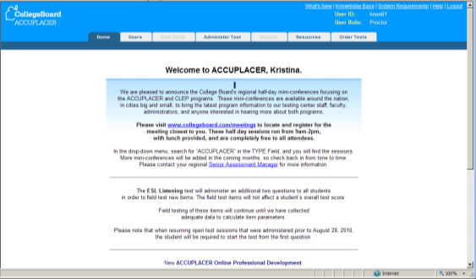

8. Click on Manage Open Test Session
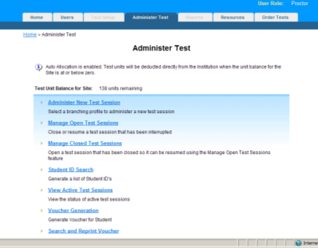

- Enter only the date in the Search Filter. Enter the date you started the test in both sections: Created date from and Created date to, then Click Perform Search
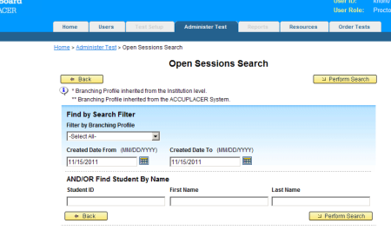

- Find your name, click on the Close Test Session Box, then click Resume
